**Individual Report**

## Customisation Menu

On the starting screen, the user has the option to pick the customisation option, on this menu, the user can pick between a background colour that they would like to use on their playthrough.

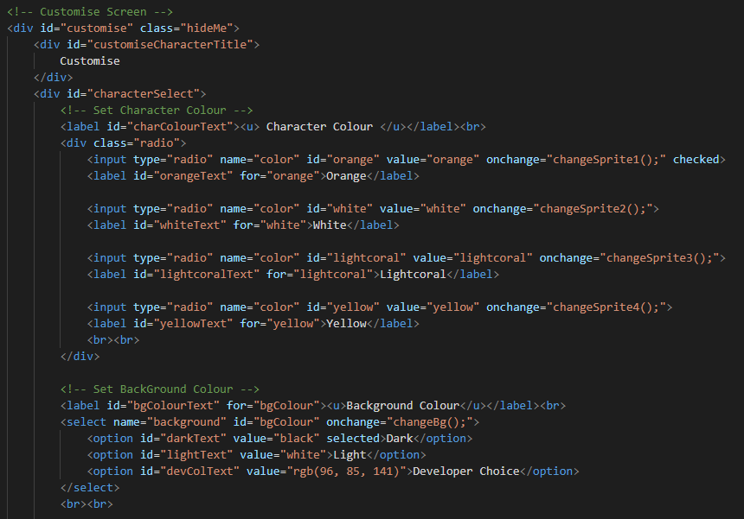

*Fig 2. Customisation HTML*

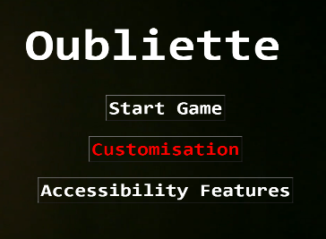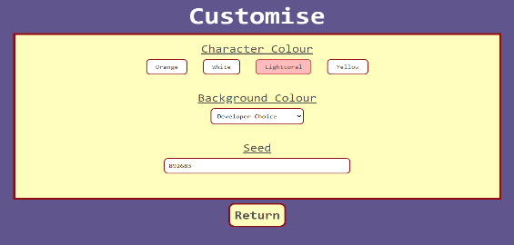

*Fig 1. Customisation screen*

The whole menu is inside the div customise. The class name can be changed to showMe or hideMe depending on whether this menu is to be shown or not. The character colour options each have their own functions, which when clicked will change the colour of the players character by altering a variables value with the value of the corresponding buttons value.

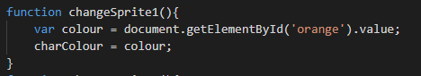

*Fig 3. This is how the character colour is changed*

*Fig 4. This is how the background colour is changed*

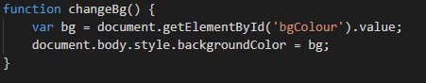

The background colour is changed by fetching the value of the selected option and altering the background colour of the body with the value of the corresponding selected option.

## Main game buttons

When the user hits begin, below the game screen there are 4 buttons which the user can use to make their character go up, down, left, or right. These buttons are also used in most of the challenges as well, where they have their functions and inner text changed to suit the challenge they are being used on. This was done so that the user wouldn’t be confused when they are presented with different types of buttons for different types of challenges.

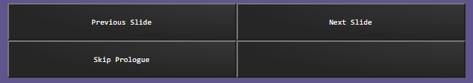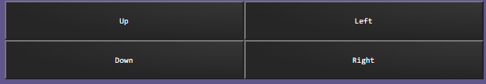

*Fig 5. Two examples of the use of my buttons*

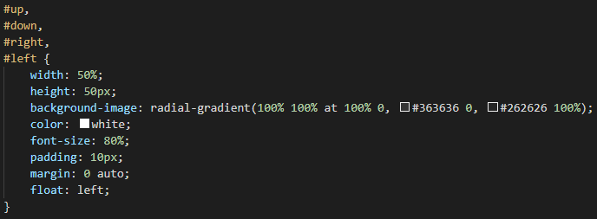

*Fig 6. Buttons CSS*

As previously said, these buttons are used in most of the challenges, including the challenge that I made myself, which brings me on to my next point.

## Spider Encounter

When the user encounters the spider challenge, they are given 4 options to choose from. The first option will allow the user to pass without punishment, however, the other 3 options will punish the player by taking away one of their lives. To stay true to the text-based adventure genre, the options describe what the player would do if they were actually in the maze, for example, they could hit it with their torch to try and get by, or punch it, or try to run past.

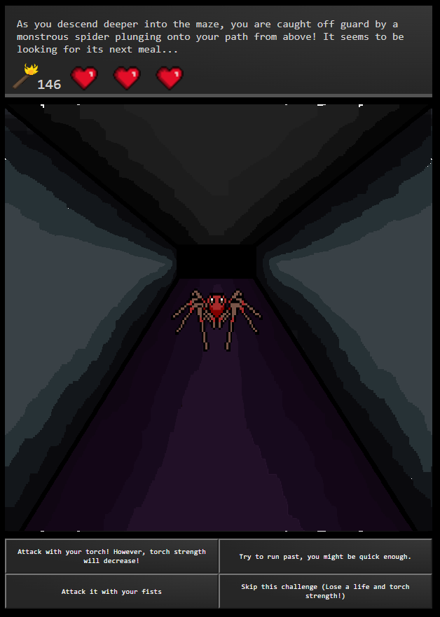

*Fig 7. User runs into the spider.*

Furthermore, if the user picks the fourth option, it will allow them to skip the level. This will still punish the player, and they will also lose out on the opportunity to increase the strength of their torch (so that they can see a greater distance in the maze). When the user picks an option, it will change the image on the screen to a relative image based on what they pick. The story box at the top will also change text, depending on what option the user pick, to continue the story.

## End screen

The end screen is displayed when the user beats the game, runs out of lives, or if the timer runs out. At the top of the screen, a relative game over message is displayed. In figure 9, I beat the game, so ‘Well done, (character name). You won!’ is displayed. Below this, the hearts are displayed, if the user beats the game with all their lives remaining, they will have 3 red hearts, if they lost one life, one of the red hearts will be greyed out.

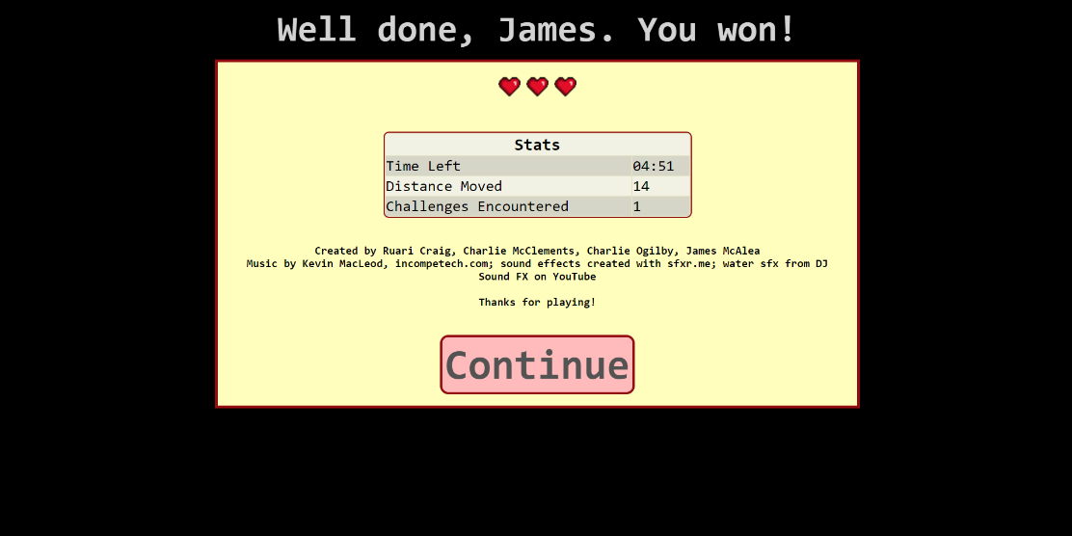

*Fig 9. The end screen*

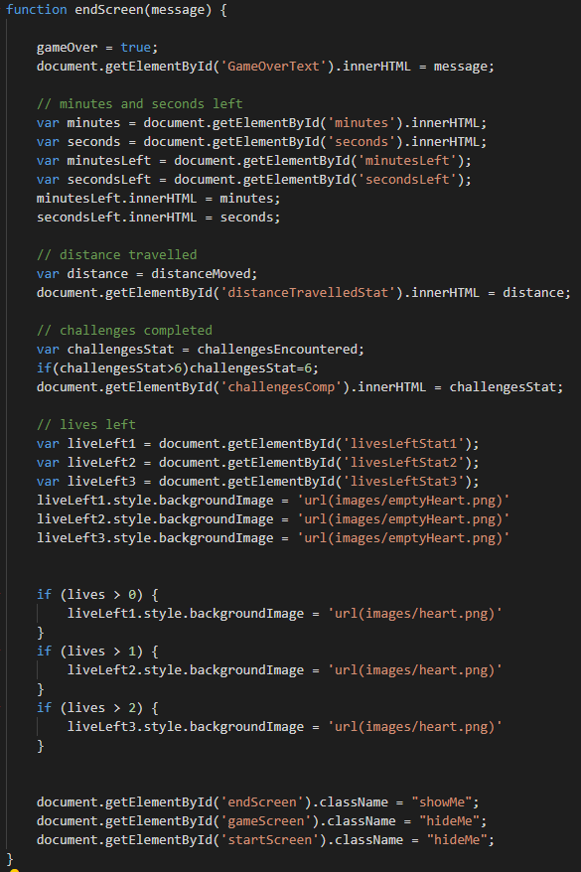

*Fig 8. The end screen JavaScript*

After the lives displayed, there is a HTML table which displays statistics about the game the user just played. The time left row fetches the value of the timer in game at the moment of the endScreen() function being called, and then it is displayed in this table.

The distance travelled statistic fetches a variable which is incremented as the user moves through the level, (each square moved = +1 distance).

The challenges encountered statistic is another variable which is incremented when the user plays a challenge.

The continue button at the bottom will refresh the page.